Traffic Shaping algorithms in C – the two classic ones are:
Leaky Bucket algorithm
Token Bucket algorithm
- Algorithm: Leaky Bucket
- The Leaky Bucket Algorithm is a traffic shaping and rate-limiting technique used in computer networks to control the rate at which data packets are transmitted.
- It ensures that network traffic flows smoothly, preventing bursts that can cause congestion.

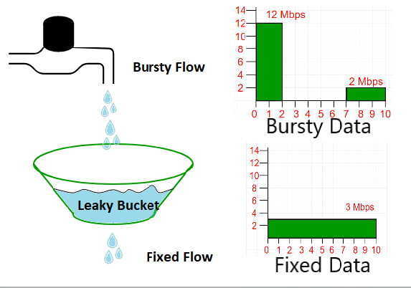

Working of Leaky Bucket Algorithm

A Leaky Bucket algorithm uses a FIFO queue to regulate traffic. For fixed-size packets, a constant number are removed at each clock tick.

Imagine a bucket with a small hole at the bottom:
- Water (packets) is poured into the bucket at varying rates.
- Water leaks out of the hole at a constant rate.
- If the bucket overflows (too many packets arrive too fast), the excess packets are discarded.

Let:
- R = constant output rate (packets per second)
- B = bucket size (maximum capacity of the queue)
- arriving packets = data packets arriving at variable intervals

Steps:
- When a packet arrives:
  - If the bucket (queue) has space, the packet is added.
  - If the bucket is full, the packet is discarded (overflow).
- The bucket leaks (sends out) packets at a constant rate R.

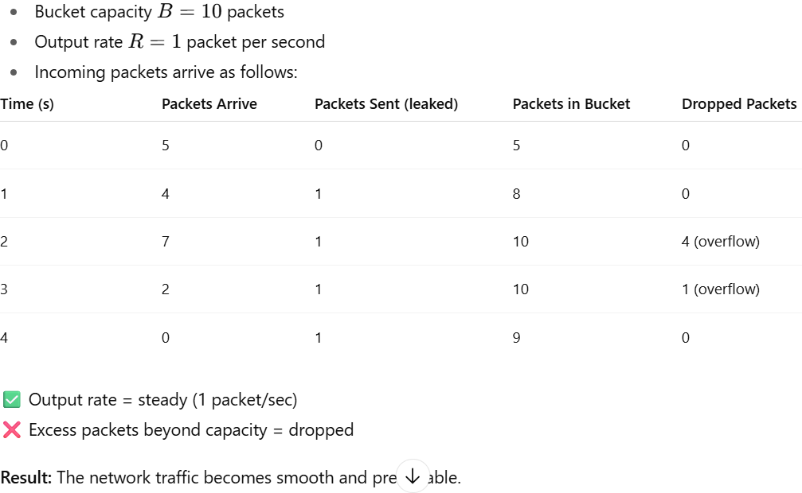

Input:
- Bucket capacity B
- Outgoing rate R
- Number of time units N
- Number of incoming packets in each time unit P[i]

Algorithm steps:
- Initialize:
  - Set stored = 0 // number of packets currently in bucket
- For each time unit i from 1 to N:
a. Read number of incoming packets P[i]
b. Check if stored + P[i] > B
  - If yes:
    - Packet overflow = stored + P[i] - B
    - Drop the overflow packets
    - Set stored = B
  - Else:
    - stored = stored + P[i]
c. If stored <= R:
  - Send all packets (stored)
  - stored = 0
d. Else:
  - Send R packets
  - stored = stored - R
e. Print number of packets sent and packets left in bucket
- After all time units:
  - While stored > 0:
    - If stored <= R:
      - Send all remaining packets
      - stored = 0
    - Else:
      - Send R packets
      - stored = stored - R
- End
- Fixed output rate R
- Excess incoming packets beyond capacity B are dropped
- Smoothens bursty input to fixed output rate

Leaky Bucket Algorithm (C Program)
This simulates a fixed-rate outflow of packets, buffering bursty input.
#include <stdio.h>

int main() {
int bucket_size, n, i, incoming, outgoing, stored = 0;

printf("Leaky Bucket Algorithm Simulation\n");
printf("Enter bucket size (capacity): ");
scanf("%d", &bucket_size);
printf("Enter outgoing rate: ");
scanf("%d", &outgoing);
printf("Enter number of packets (time units): ");
scanf("%d", &n);

for(i=0; i<n; i++) {
printf("\nTime unit %d:\n", i+1);
printf("Enter number of incoming packets: ");
scanf("%d", &incoming);

if(incoming + stored > bucket_size) {
printf("Bucket overflow! Packet loss = %d\n", incoming + stored - bucket_size);
stored = bucket_size;
} else {
stored += incoming;
}

if(stored <= outgoing) {
printf("Packets sent: %d\n", stored);
stored = 0;
} else {
printf("Packets sent: %d\n", outgoing);
stored -= outgoing;
}

printf("Packets remaining in bucket: %d\n", stored);
}

// Drain remaining packets
while(stored > 0) {
printf("\nDraining remaining packets...\n");
if(stored <= outgoing) {
printf("Packets sent: %d\n", stored);
stored = 0;
} else {
printf("Packets sent: %d\n", outgoing);
stored -= outgoing;
}
printf("Packets left in bucket: %d\n", stored);
}

printf("\nSimulation complete.\n");
return 0;
}
- Algorithm: Token Bucket
Input:
- Bucket capacity B (max tokens)
- Token generation rate R (tokens added per time unit)
- Number of time units N
- Number of packets to send in each time unit P[i]

Algorithm steps:
- Initialize:
  - Set tokens = 0 // current number of tokens
- For each time unit i from 1 to N:
a. Add R tokens: tokens = tokens + R
b. If tokens > B:
  - tokens = B
c. Read number of packets to send P[i]
d. If tokens >= P[i]:
  - Send P[i] packets
  - tokens = tokens - P[i]
e. Else:
  - Send tokens packets
  - Packets dropped = P[i] - tokens
  - tokens = 0
f. Print packets sent, tokens left, and packets dropped
- End
- Allows bursty traffic if enough tokens are available
- Tokens accumulate up to capacity B
- Packets sent depend on available tokens; excess packets are dropped

Token Bucket Algorithm (C Program)
This allows burstiness controlled by tokens.
#include <stdio.h>

int main() {
int bucket_size, n, rate, tokens = 0, incoming, i;

printf("Token Bucket Algorithm Simulation\n");
printf("Enter bucket size (capacity): ");
scanf("%d", &bucket_size);
printf("Enter token generation rate: ");
scanf("%d", &rate);
printf("Enter number of packets (time units): ");
scanf("%d", &n);

for(i=0; i<n; i++) {
printf("\nTime unit %d:\n", i+1);

tokens += rate;
if(tokens > bucket_size) tokens = bucket_size;

printf("Enter number of packets to send: ");
scanf("%d", &incoming);

if(tokens >= incoming) {
printf("Packets sent: %d\n", incoming);
tokens -= incoming;
} else {
printf("Only %d tokens available, packets sent: %d, packets dropped: %d\n",
tokens, tokens, incoming - tokens);
tokens = 0;
}

printf("Tokens left: %d\n", tokens);
}

printf("\nSimulation complete.\n");
return 0;
}
To compile & run (same for both):
gcc leaky_bucket.c -o leaky
./leaky
or
gcc token_bucket.c -o token
./token

Explanation Leaky bucket keeps fixed outflow, dropping excess.
- Token bucket allows bursts as long as tokens are available.

